Dorby Frocks

Customized Actual Style Cost Sheet Report by PO #
Ref#101828

Overview:

A custom style cost sheet form will be developed to allow the users of Dorby Frock, Inc. to be able to print the detailed style cost sheet based on a specific purchase order.
An estimated cost sheet by style will be created in the system. The user will then create a purchase order and a purchase order cost sheet. The purchase order cost sheets, are specific to a customer. In addition, the estimated yields are adjusted on the style purchase order based on actual marker yields.
We will create a form that will allow the user to view the detailed cost sheet by style, based on the adjusted yields and costs of each purchase orders created.

The interface will be similar to the style costing output.
The user will be able to select a specific style, and/or style PO number.
The top portion of the form will display generic style information along with Price and cost information.
The body of the form will display the details of the style components, by costing category, these components will be displayed in a different sequence than the standard screen:

This form will be printed on a Laser – use FRX
Print 1 style per page
Only print components for 1st style color on PO if multiple colors on PO

I – Selection Grid
If Style is Picked ‘in List’, Style PO will only display/browse PO numbers that contain that style #

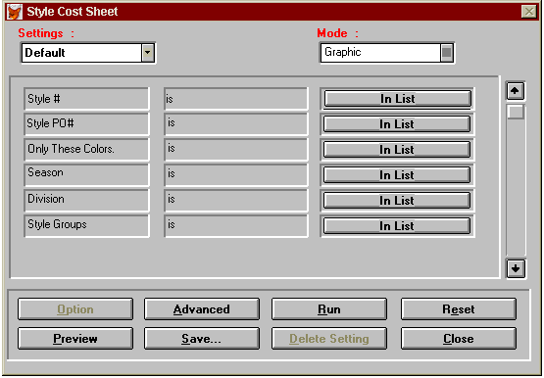

Detailed specifications:

- Output:
II - List of fields:
# | Field Name | Comments
1 | Style | Style number from the style file (STYLE.CSTYMAJOR)
2 | Purchase Order | Purchase Order number (BOMLINE.CTKTNO for cimtyp=I)
3 | Customer | Customer code from style PO Buyer field POSHDR.BUYER
4 | Color | Style color. The system will print the first color for the style + PO selected. (BOMLINE.STYLE –non major = value after -)
5 | Description | Style Description (STYLE.DESC)
6 | Season | Style season (STYLE.SEASON)
7 | Division | Style Division (STYLE.CDIVISION)
8 | Sizes | Style size scale (STYLE.SCALE) and the screen will display the corresponding size scale descriptions
9 | S. Price | Style selling price from PO header custom field = POSHDR.NSELLPRICE
10 | Gross profit | S. Price – total cost
11 | Gross profit % | (S. Price – total cost) / S. Price
12 | Total cost | Total cost sheet (sum of all components unit cost *qty )

III - Internal processing – output:

Based on the user selection of style and PO, the program will compile the information and display the detail of the cost components by style/color from the BOMLINE file.
The detail form will display the items sorted by cost category:
Ccatgtyp = 1. F / 2. T / 3. P / 4. D / 5. M
The cost category will be displayed in the first column for the first item of that category (see sample layout).

# | Column | Comments
1 | Category type | Print the category type only for the first item of this category.
2 | Item | Item code (BOMLINE.ITEM)
3 | l.clr | Item color (BOMLINE.LCLR)
4 | Description | Item description (FABRIC.DESC). We will have to create an index tag to the fabric file as the item could have been added from the style PO directly and not be listed in the BOM file of the selected style.
5 | UOM | Item Unit of Measure (FABRIC.UOMUSE)
6 | Unt Qty | Item quantity (or yield) (BOMLINE.UNITQTY)
7 | Unt Cst | Item unit cost (BOMLINE.UNITCOST)
8 | Total Cst | Item Total cost (UNITQTY*UNITCOST)

IV - Layout

REPORT NAME |  |  |  | COMPANY NAME |  |  |  |  | DATE
TIME OF REPORT |  |  |  | ACTUAL STYLE COST SHEET |  |  |  |  | PAGE# 1 OF
**************************************************************************************************************************************************
Style: |  | Color: |  | Description: |  |  |  | Customer:
PO#: |  | Season: |  |  | Division:
Sizes
--------------------------------------------------------------------------------------------------------------------------------------------------------------------------------
SELLING PRICE |  |  | GROSS PROFIT |  |  | % |  | TOTAL COST
---------------------------------------------------------------------------------------------------------------------------------------------------------------------------------
 | Item | I. Clr | Description |  |  |  | UOM | Unt Qty | Unt Cst | Total Cst
Fabric
 |  |  | Sub Total:
Trims
 |  |  | Sub Total:
Labor
Duty
 |  |  | Sub Total:
Mfg. Oper.
 |  |  | Sub Total:

